

**Palliative Care ECHO 4.0 Improving Care for those with Serious Illness**



Palliative care clinicians manage complex symptoms, work with patients and families to establish goal aligned care, and strive to improve the quality of life for those with serious illness. Most clinicians can provide primary palliative care for those with serious illness and at the end of life. In Year 4 of the Interprofessional Palliative ECHO® program, we will expand on pertinent topics to look at the palliative care in situations and settings through didactic presentations and participants’ case-based presentations in this teach-teach/learn-learn model. Clinicians will acquire skills and establish professional connections to improve the care of patients with serious illness and at the end-of-life. **Participation in Years 1-3 Palliative ECHO is not required. Didactics from Years 1-3 will be accessible for review.**



First Tuesday of the month 12:00-1:00 pm

Physicians

|  |  |
| --- | --- |
| October 1, 2024 | Trauma- Informed Care |
| November 5, 2024 | Palliative Care in the Emergency Department |
| December 3, 2024 | LGBTQIA+ Care in Serious Illness |
| January 7, 2025 | Medical Aid in Dying and Voluntary Stopping Eating and Drinking |
| February 4, 2025 | Severe Mental Illness as a Life-Limiting Illness |
| March 4, 2025 | Serious Illness Conversation Guidance in Dementia |
| April 1, 2025 | Spirituality and Cultural Sensitivity in Serious illness |
| May 6, 2025 | Neurological diseases – evidence for navigating care partner stress |
| June 3, 2025 | Pediatric Palliative Care in the Region |

Advance Practice Providers

Nursing professionals

Social Workers

Physical/Occupational therapists

Chaplains

Counselors

Behavioral health providers

Volunteers

Anyone who cares for patients with serious illness



# Email: [ECHO@hitchcock.org](mailto:ECHO@hitchcock.org)

**Website:**

<https://go.d-h.org/project-echo>

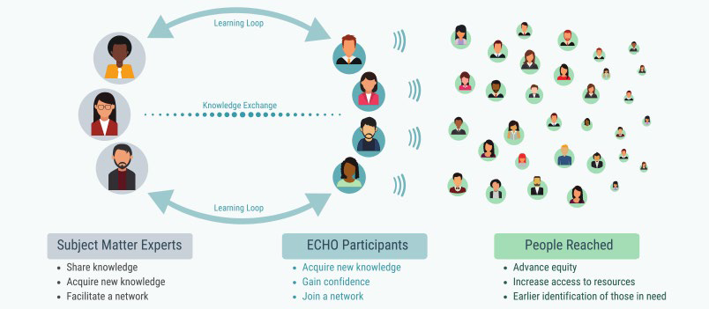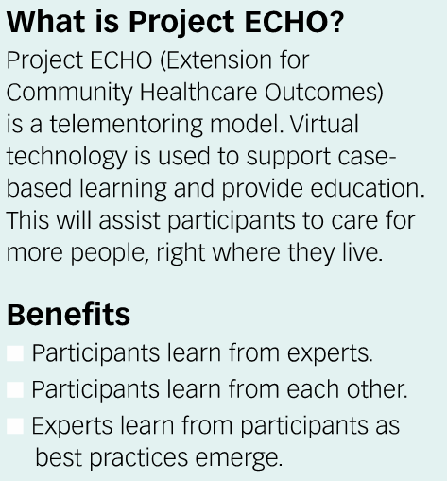

To register, visit the [iECHO Registration Site](https://iecho.org/public/program/PRGM1722353975720FA9FH01BQ2)



* Sessions are free of charge. Continuing Medical Education (CME) Continuing Nursing Education (CNE) and Continued Pharmacy Education will be offered, see below for details.

# Learning Objective:

**Continuing Education Information**

# At the conclusion of this learning activity, participants will be able to:

Discuss at least two ways to enhance care of patients with serious illness including improved management of symptoms and ability to better address goals of care with patients.

**Accreditation:**

In support of improving patient care, Dartmouth Health is jointly accredited by the Accreditation Council for Continuing Medical Education (ACCME), the Accreditation Council for Pharmacy Education (ACPE), and the American Nurses Credentialing Center (ANCC) to provide continuing education for the healthcare team.

American Medical Association (AMA)  
Dartmouth Health designates this Live Activity for a maximum of 9.0 *AMA PRA Category 1 CreditsTM.*Physicians should claim only the credit commensurate with the extent of their participation in the activity.

American Nurses Credentialing Center (ANCC)  
Dartmouth Health designates this Live Activity for a maximum of 9.00 ANCC contact hours.

Accreditation Council of Pharmacy Education (ACPE)  
Dartmouth Health designates this knowledge-based activity for a maximum of 9.00 hours. Credit will be provided to NABP CPE Monitor within 60 days after the activity completion.

UAN JA0000201-0000-24-012-L99-P UAN JA0000201-0000-24-012-L99-T

All other learners may claim CME-designated participation credit. Consult your professional licensing board regarding the applicability and acceptance of CME-designated participation credit for programs certified for credit by organizations accredited by Joint Accreditation for Interprofessional Education.



|  |  |
| --- | --- |
|  |  |
|  |  |